TRAINING ON BREAD MAKING
Healthy Foods for Consumers Initiative (HeFci) Training of women on bread making and pudding using Pro Vitamin-A Cassava, for Value Chain Development Programme (VCDP), Anambra State, on December 20th, 2019, at Nnamdi Azikiwe University Bakery, Awka, Anambra State, Nigeria.

Professor Nkiru T. Meludu during the theoretical class
The bread after baked.
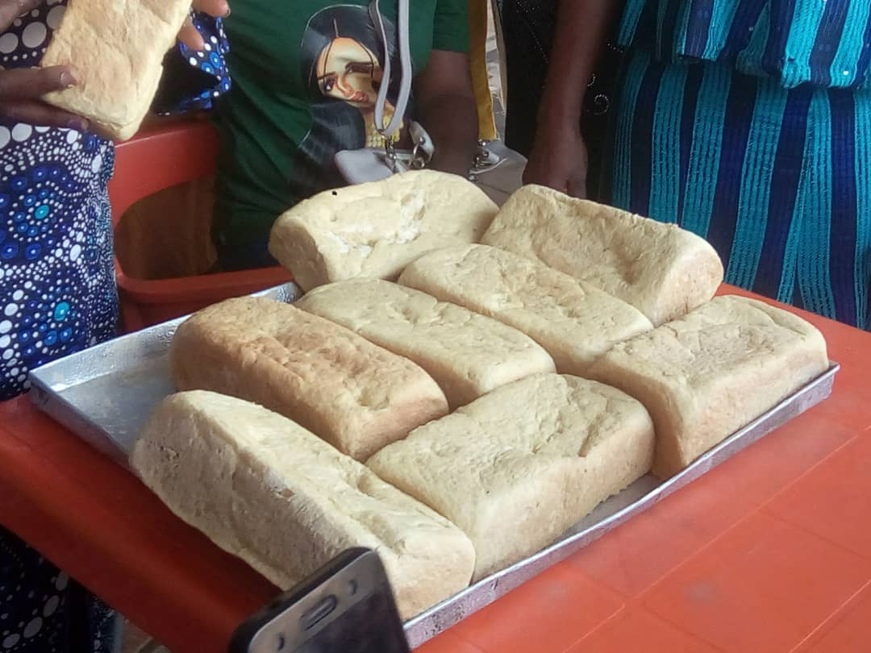
Testing of the bread baked
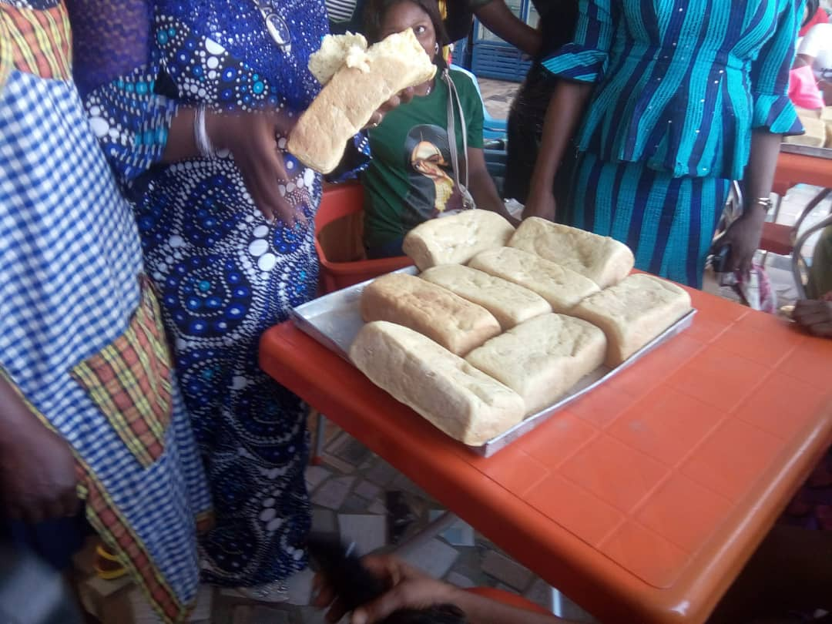
Cross section of women participated in the training
